Save & Exit Submit
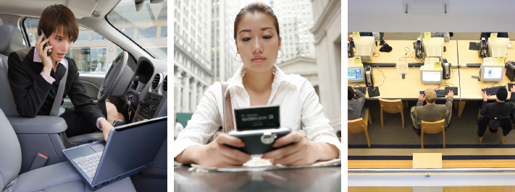
Twitter
Twitter, a privately funded start-up, is a pioneer in the microblogging arena providing a service that allows users to send and receive updates to other users. Twitter customers can keep a network of friends informed of their current status by way of text messaging, instant messaging, email, or the web. Friends, family, and coworkers use Twitter’s services to communicate and stay connected through a real-time short messaging service that works over multiple networks and devices. Twitter began as a small project in 2006 and has developed into one of the most popular sites on the Internet. People around the globe use Twitter for various reasons from breaking world news to streamlining business.
The Business of Twitter
Companies are using Twitter to follow customer dialogs about their brand. Comcast, Dell, General Motors, H&R Block, Kodak, and Whole Foods Market are using Twitter to do everything from building brand awareness to providing customer service. The attention to Twitter reflects the power of new social media tools in letting consumers shape public discussion over brands. “The real control of the brand has moved into the customer’s hands, and technology has enabled that,” says Lane Becker, president of Get Satisfaction, a website that draws together customers and companies to answer each other’s questions and give feedback on products and services.
JetBlue, Comcast, and H&R Block are among the companies that recognize Twitter’s potential in providing customer service. A single Twitter message—known informally as a tweet —sent in frustration over a product’s or a service’s performance can be read by hundreds or thousands of people. Similarly, positive interaction with a representative of the manufacturer or service provider can help change an influencer’s perspective for the better. For companies, tools such as Tweetscan or Twitter’s own search tool, formerly known as Summize, make it easy to unearth a company’s name mentioned in tweets. Being able to address an issue the moment it appears is a great way to improve customer satisfaction
GM took notice the day a prospective buyer was at a Saturn dealership, ready to make a purchase, but could not find anyone to help him. “He was starting to get upset about it,” says Adam Denison, who helps coordinate social media communications at GM. “When we saw it, we immediately let our Saturn colleagues know about it . . . and they could get the ball rolling a little bit better.” The person bought a Saturn in the end—though at a different dealership, Denison says.
Monitoring Customers
Not all customers want Corporate America following their tweets. Jonathan Fields typed a quick tweet to his friends when he spotted William Shatner waiting to board a JetBlue flight at New York’s JFK airport. Fields wrote: “JetBlue terminal, William Shatner waiting in pinstripe suit and shades to board flight to Burbank. Why’s he flying JetBlue? Free, maybe?” To his surprise he received a reply within 10 seconds, but not from his friends; it was from JetBlue informing Fields that they were following him on Twitter. Fields was at first shocked by the reply, then the JetBlue employee Morgan Johnston quickly explained that the company was not spying on Fields, but uses Twitter as a scanning tool, to find customers who might need information, say, on flight delays or cancellations.
“It has potential for delivering business value, clearly, but at the same time there are some risks to it,” says Ray Valdes, research director of web services at consulting firm Gartner. While it is a useful brand-monitoring tool, it “can come across as a little creepy.” Christofer Hoff tweeted his displeasure with Southwest when his flight was delayed and his luggage disappeared. The next day he received the following message from Southwest: “Sorry to hear about your flight—weather was terrible in the NE. Hope you give us a 2nd chance to prove that Southwest = Awesomeness.” In a blog post about the incident, Hoff wrote that it was “cool and frightening at the same time.”
Twitter Ethics
Of course with all great good comes the potential of great evil and Twitter is no exception. A few individuals purchased unofficial accounts to send messages that were clearly not authorized by the company. For example, ExxonMobil discovered that a person named Janet was fooling many people by posing as an employee of ExxonMobil. “Our concern was that people reading the postings would think that this person was speaking on the company’s behalf,” says ExxonMobil spokesman Chris Welberry. “We didn’t want to do anything heavyhanded about people expressing their views in a social networking environment. We just wanted to make sure that people who are doing that are open and transparent.”
After Exxon discovered Janet, the company contacted Twitter. “Twitter does not allow impersonation or domain squatting, which is grabbing a user name and saying you want money,” Twitter co-founder Biz Stone says. “But they really do have to be impersonating or infringing on copyright. If somebody’s last name happens to be Mobil, the company does not have a strong case there.” Janet’s account was taken out of commission.
Twitter Growth
Large organizations are likely to begin integrating microblogging into their existing services to aggregate the various social media outposts. Facebook is already positioning itself to be an aggregator of microblogging sites. The social network’s News Feed feature lets people pull in updates from Twitter, Blip.fm, and elsewhere. How valuable could a microblogging service be? Soon after Twitter raised $15 million in funding, it was speculated that the site may be worth as much as $1 billion. Twitter co-founder Biz Stone expects the site’s user base to grow 10 times its current size yearly.
1.
value:
50.00 points
Note: This question will not be automatically graded.
It will be sent to your instructor for review.
Required information

Why do 21st-century organizations need to understand the power of micro-blogging?
References
WorksheetDifficulty: 2 Medium

2.
value:
50.00 points
Note: This question will not be automatically graded.
It will be sent to your instructor for review.
Required information

What types of ethical and security issues should a company using Twitter anticipate?
References
WorksheetDifficulty: 2 Medium

